CENTRALIZED LOGGING USING FILEBEAT AND LOGSTASH

Introduction
:::info
Logs are stored for each and every request made by the user. For each request, one server is assigned. To check for any event we need to search the particular server. This is where the Central Logging System comes to play.
:::

Using Filebeat and Logstash
:::info
Filebeat is one of the best log file shippers out there today — it’s lightweight, supports SSL and TLS encryption, supports back pressure with a good built-in recovery mechanism, and is extremely reliable. It cannot, however, in most cases, turn your logs into easy-to-analyze structured log messages using filters for log enhancements. That’s the role played by Logstash.
Logstash acts as an aggregator — pulling data from various sources before pushing it down the pipeline.
The relationship between the two log shippers can be better understood in the following diagram

:::

Installation

Filebeat
:::warning
To download and install Filebeat, use the commands that work with your system.
deb:
curl -L -O https://artifacts.elastic.co/downloads/beats/filebeat/filebeat-6.5.4-amd64.deb sudo dpkg -i filebeat-6.5.4-amd64.deb
mac:
curl -L -O https://artifacts.elastic.co/downloads/beats/filebeat/filebeat-6.5.4-darwin-x86_64.tar.gz tar xzvf filebeat-6.5.4-darwin-x86_64.tar.gz
linux
curl -L -O https://artifacts.elastic.co/downloads/beats/filebeat/filebeat-6.5.4-linux-x86_64.tar.gz tar xzvf filebeat-6.5.4-linux-x86_64.tar.gz
Windows:
- Download the Filebeat Windows zip file from the downloads page .
- Extract the contents of the zip file into C:\Program Files .
- Rename the filebeat- -windows directory to Filebeat .
- Open a PowerShell prompt as an Administrator (right-click the PowerShell icon and select Run As Administrator ).
- From the PowerShell prompt, run the following commands to install Filebeat as a Windows service:
PS > cd 'C:\Program Files\Filebeat' PS C:\Program Files\Filebeat> .\install-service-filebeat.ps1
Try official_page in need for more info.
:::

Logstash
:::warning
Logstash requires Java 8. Java 9 is not supported. Use the official Oracle distribution or an open-source distribution such as OpenJDK.
To check your Java version, run the following command:
java -version
On systems with Java installed, this command produces output similar to the following:
java version "1.8.0_65" Java(TM) SE Runtime Environment (build 1.8.0_65-b17) Java HotSpot(TM) 64-Bit Server VM (build 25.65-b01, mixed mode)
Download and install the Public Signing Key:
wget -qO - https://artifacts.elastic.co/GPG-KEY-elasticsearch | sudo apt-key add -
You may need to install the apt-transport-https package on Debian before proceeding:
sudo apt-get install apt-transport-https
Save the repository definition to /etc/apt/sources.list.d/elastic-6.x.list :
echo "deb https://artifacts.elastic.co/packages/6.x/apt stable main" | sudo tee -a /etc/apt/sources.list.d/elastic-6.x.list
Run sudo apt-get update and the repository is ready for use. You can install it with:
sudo apt-get update && sudo apt-get install logstash
Try official_page for installation using Yum,Docker,etc.
:::

Working

Step 1: Configure Filebeat
:::danger
To configure Filebeat, you need to edit the configuration file. The default configuration file is called filebeat.yml . The location of the file varies by platform. To locate the file, see Directory layout.
There’s also a full example configuration file called filebeat.reference.yml that shows all non-deprecated options.
filebeat.yml
#----------- filebeat prospectors ---------- filebeat.prospectors: - type: log paths: - /path/to/log/file - /other/path/to/file fields: app_id: xyz_apps # Closes file handler when a file gets rotated file_renamed: true close_inactive: 10m scan_frequency: 30s max_procs: 2 #limit CPU usage to 200% #-------------- Filebeat modules ------------- filebeat.config.modules: # Glob pattern for configuration loading path: ${path.config}/modules.d/*.yml # Set to true to enable config reloading reload.enabled: false #--------------- Logstash output ------------ output.logstash: hosts: ["127.0.0.1:5046"] protocol: "http"
Try configure_filebeat for more info
:::

Step 2: Configure Logstash
:::danger
To configure Logstash, you create a config file that specifies which plugins you want to use and settings for each plugin. You can reference event fields in a configuration and use conditionals to process events when they meet certain criteria. When you run logstash, you use the -f to specify your config file.
A Logstash config file has a separate section for each type of plugin you want to add to the event processing pipeline.
logstash.conf
# Input Here input { beats { port => 5046 } } # Manipulate Input filter { if "xyz.log" in [source] { mutate { replace => ["[fields][app_id]", "xyz"] } } } #Output Here output { # xyz logs if "xyz.log" in [source] { file { path => "/path/to/central_logs/%{[fields][env]}/%{[beat][name]}/%{[fields][app_id]}/xyz.%{+dd-MM-YYY}.log" codec => line{format => "%{message}"} } } }
Try configure_logstash for more info
:::

Step 3: Run Commands
:::success
To avoid missing any logs, we start with logstash.
- Run Logstash
/usr/share/logstash/bin/logstash -f /path/to/configation_file.conf
- Check Status
sudo service logstash status
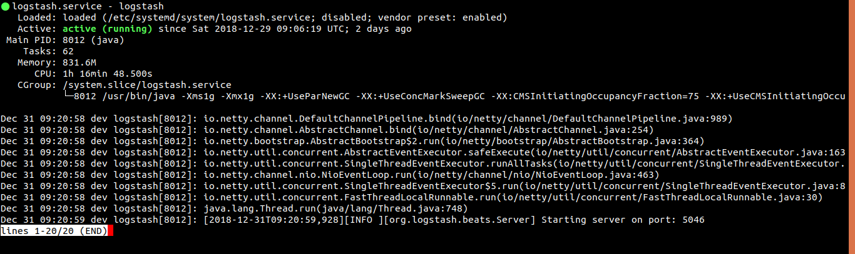
- Running service should look like this
- There are many other options available to run logsatash
We can now run filebeat to send the logs.
- Start filebeat
sudo service filebeat start
- Check Status
sudo service filebeat status
- Running filebeat should look like this
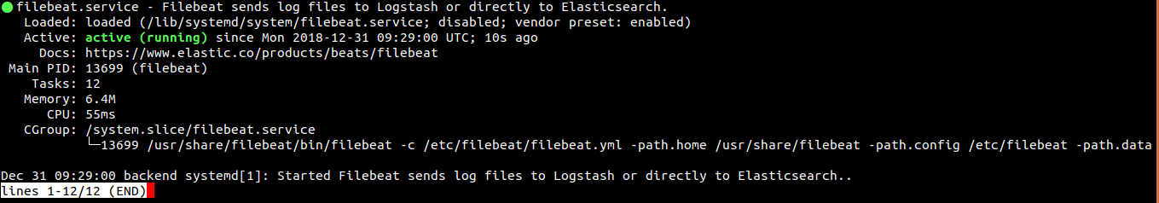
- Try start_filebeat for more info on starting filebeat
:::

Deployment using Ansible
:::info
We can use ‘Ansible’ to deploy ‘Filebeat’ and ‘Logstash’ to designated servers.
- Deploying filebeat
--- - hosts: servers gather_facts: false become: yes tasks: - name: Copying filebeat package command: src=config_files/filebeat-6.5.4-amd64.deb dest=/tmp/filebeat-6.5.4-amd64.deb - name: Downloading filebeat package command: curl -L -o /tmp/filebeat-6.5.4-amd64.deb "https://artifacts.elastic.co/downloads/beats/filebeat/filebeat-6.5.4-amd64.deb" - name: Installing filebeat command: dpkg -i /tmp/filebeat-6.5.4-amd64.deb - name: Copying filebeat config template: src=config_files/filebeat.yml dest=/etc/filebeat/filebeat.yml - name: Stoping Filebeat command: service filebeat stop - name: Starting Filebeat command: service filebeat start # vim:ft=ansible:
- Deploying logstash
- download the public key using wget -qO - https://artifacts.elastic.co/GPG-KEY-elasticsearch
--- - hosts: all gather_facts: false become: yes tasks: - name: "Copying key" copy: src=/path/to/key/GPG-KEY-elasticsearch dest=/path/to/copy/GPG-KEY-elasticsearch owner=root group=root mode=0644 - name: "Adding key" command: apt-key add /copied/path/of/GPG-KEY-elasticsearch - name: "Installing transport package" command: apt-get install apt-transport-https - name: "Saving repository" command: echo "deb https://artifacts.elastic.co/packages/6.x/apt stable main" | tee -a /etc/apt/sources.list.d/elastic-6.x.list - name: "Installing logstash" command: apt-get update - name: "Installing logstash..." command: apt-get install logstash - name: "Copying configuration files" copy: src=/path/to/logstash.conf dest=/etc/logstash/conf.d/logstash.conf owner=root group=root mode=0644 - name: "Starting logstash" command: /usr/share/logstash/bin/logstash -f /path/to/configation_file.conf # vim:ft=ansible:
:::

